THACH LOI PRIMARY SCHOOL  Full name: .................................................  Class: 3…… | THE FIRST TERM TEST  SCHOOL YEAR 2023-2024  SUBJECT: ENGLISH - GRADE 3  TIME: 35 minutes
Marks | Listening | Reading and writing | Speaking | Total

PART 1. LISTENNING
1. Listen and circle. (Nghe và khoanh tròn) (2pt)
1. a. We play badminton at school.
b. I have a blue notebook.
2. a. This is my new pen.
b. There are five pencils.
3. a. They are my books.
b. Let’s go home!
4. a. Stand up, please!
b. Can you speak louder, Mai?
2. Listen and tick.( Nghe và tích) (2pt)
1 | 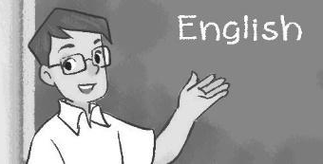  a.❑ | 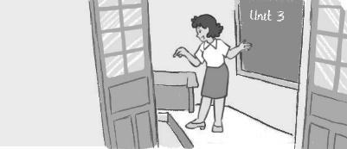  b.❑ | 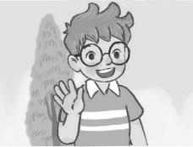  c.❑
2 | a.❑ | 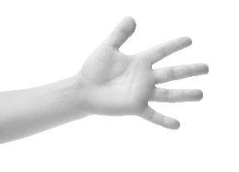  b.❑ | 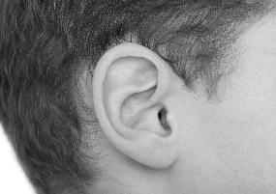  c.❑
3 | 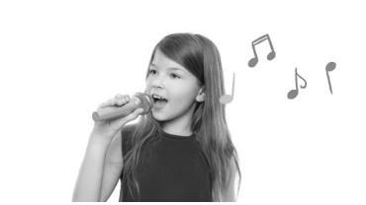  a.❑ | b.❑ | c.❑
4 | 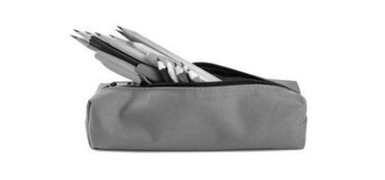a.❑ | 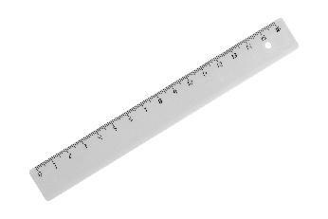  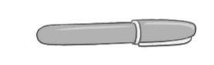  b.❑ | 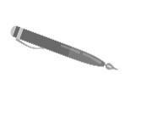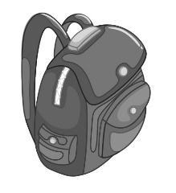  c.❑

PART 2: READING AND WRITING
3. Read and tick. (Đọc và tích) (1pt)
1. A: Hi. I’m Nam.
B: Hi, Nam. I’m Mary.
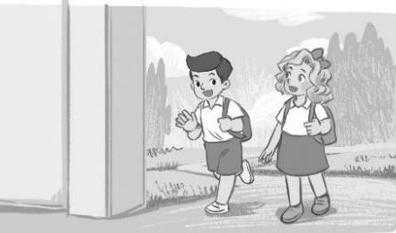  a.❑ | 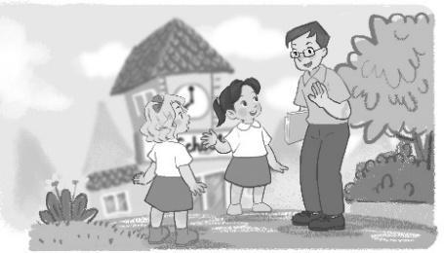  b.❑ | 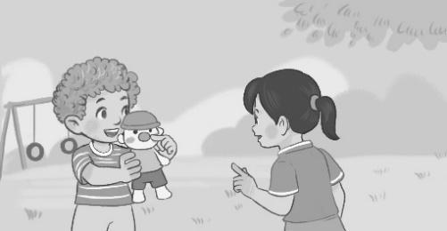 c.❑
2. A: May I come in?
B: Yes, you can.
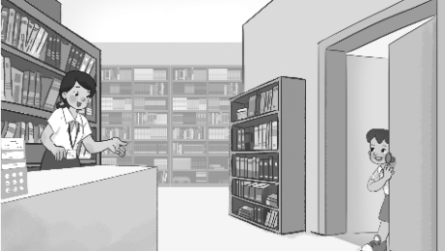  a.❑ | 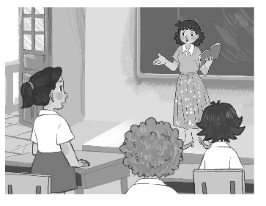 b.❑ | c.❑

3. A: Sit down and touch your eye.
B: OK.
a. ❑ b. ❑ c. ❑
4. A: What do you do at break time?
B: I play table tennis.
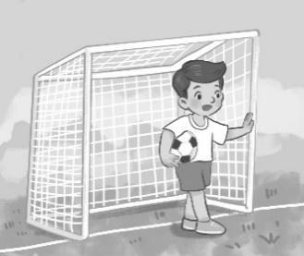  a.❑ | 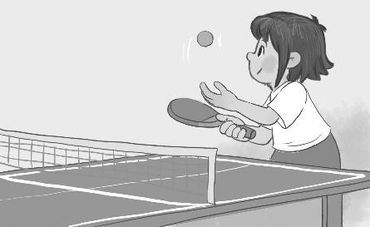  b.❑ | c.❑
4: Look and read. Write Yes or No. (Đọc và viết Yes hoặc No)(1pt)
 | 1. skating | ______ | 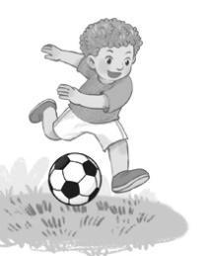 | 2. badminton | _______
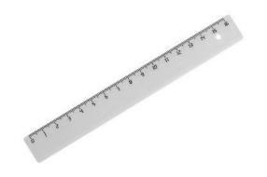 | 3.Ruler | ______ |  | 4. Stand up | _______
5. Look and write. (Nhìn và viết sao cho đúng) (2pt)
seven chess English am

Hi! I (1) ________ Nam. I’m (2) ________I like playing (3) ________. At school, my favourite subject is (4) ________.

THE END

6. Let’s talk. (2pt)
1. Greeting/  Responding to greetings | 2. Asking the pupil’s name/ age | 3. Introducing someone | 4. Asking questions about parts of the body | 5. Asking about hobbies
6. Making suggestions/ Expressing agreement | 7. Giving instructions/ Asking for permission | 8. Asking about school things | 9. Asking about the colours of school things | 10. Talking about break time activities

ANSWER KEY

1.
Audio script:
1. We play badminton at school.
2. There are five pencils.
3. Let’s go home!
4. Stand up, please!
Key: 1. a 2. b 3. b 4. a
2.
Audio script:
1. A: Ben, is that ...?
B: My teacher, Mum. Good morning, Mr Long.
2. A: What’s this?
B: A hand?
A: No, it isn’t. It’s an ear.
3. A: What’s your hobby?
B: Well, I like swimming.
4. Look, Ben. I have a pen and a ruler.
Key: 1. a 2. c 3. b 4. b
3.
1. a 2. a 3. a 4. B

4. 1. No 2. No 3. Yes 4.Yes

5.
(1) am (2) seven (3) chess (4) English
6.
Suggested questions and answers:
1. Hello, (pupil’s name). How are you? (Giving clues: Are you fine?/ OK? Yes? No?)
2. Hi! My name’s _____________. What’s your name?/ How old are you?
(Giving clues: My name’s ____./ I’m _____ and you are _______./
Are you ______? Yes? No?)
3. Is this (one pupil’s name)?
4. What’s this?/ Touch your (a body part).
(Point to any body parts learnt to ask or give commands to check pupil’s understanding.)
5. What’s your hobby? (Giving clues: Do you like (swimming)? Swimming? Yes? No?)
6. Is this __________?
Let’s ___________.
7. May ___________?
(Point to one flash card, have the pupil give instructions or ask for permission.)
8. I have _______. Do you have _______?
9. What colour is it? What colour are they? (Giving clues: Is it red? Yes? No?)
10. I play badminton at break time. What about you, (pupil’s name)?
For some topics, the teacher points to the flash card or realia, has the pupils listen and say/ respond. Depending on the pupil's speaking performance, the teacher can give him/ her some clues to encourage him/ her to speak English.

MA TRẬN ĐÁNH GIÁ KIỂM TRA MÔN TIÊNG ANH LỚP 3
HỌC KỲ 1

Kỹ năng | Nhiệm vụ đánh giá/ kiến thức cần đánh giá | Mức/ điểm |  |  |  | Tổng số câu , số điểm, tỉ lệ %
 |  | M1 | M2 | M3 | M4
Listening  4pts =40% | 1. Listen and circle |  | 1 đ  (2 câu) | 1 đ  (2 câu) |  | 4 câu = 2 điểm
 | 2. Listen and tick | 1 đ  (2 câu) | 0,5đ  (1 câu) | 0,25đ  (1câu) |  | 4 câu = 2 điểm
Reading  2 pts = 20% | 3. Read and tick (v)  4. Read and write yes or no |  | 1 đ  (4 câu) | 0,5đ  (3 câu) | 0,5đ  (1 câu) | 8 câu = 2 điểm
Writing  2 pts = 20% | 5. Look and write |  |  | 1 đ  (2 câu) | 1 đ  (2 câu) | 4 câu = 2 điểm
Speaking  2 pt = 20% | -Respond the questions of teacher. | 1đ  (4 câu) |  |  |  | 8 câu= 2 điểm
 | -Discribe the pictures in sts’ book by answering questions of teacher. | 0,5đ  (2 câu) | 0,5đ  (2 câu)
Tổng số câu |  |  |  |  |  | 28 câu

